Transfer of Heat
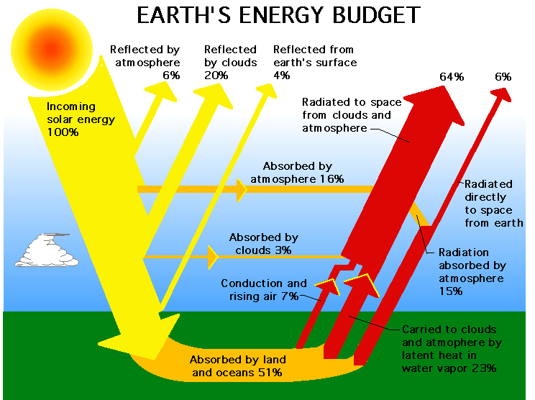
- By what process does the sun provide energy to the Earth?

- According to the diagram below, what percentage of the sun’s radiation gets absorbed by the atmosphere? How does this compare to the amount that is absorbed by land and the oceans?

- What happens to the solar energy that is absorbed by the land and oceans?

- The Earth is a good absorber of heat, and therefore a good emitter of heat. Explain how the Earth’s radiation can lead to conduction in the atmosphere.

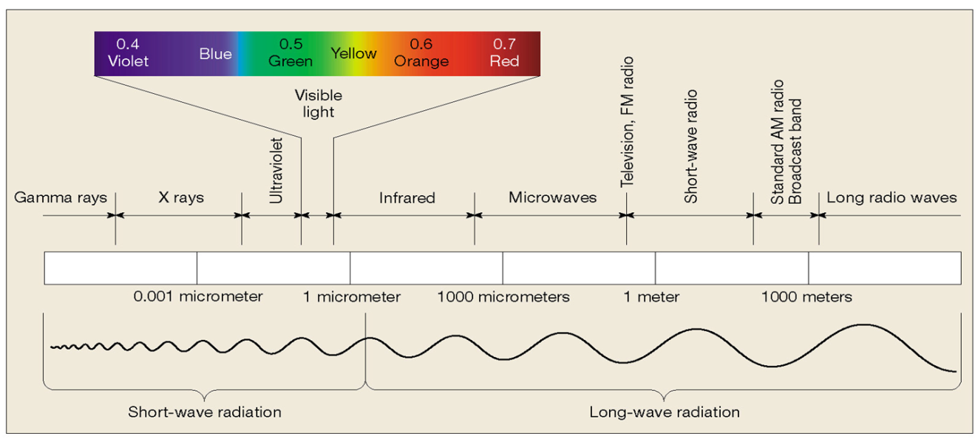
- How does the wavelength of infrared rays compare to that of visible light waves? Which wave has the greatest energy?

- When an object absorbs radiation, what happens to the temperature?

- If you were to heat a metal pot and a plastic cup to the same temperature and then allow them to cool back down to room temperature, which object do you think would cool back down the fastest? Why?

- Of the three main processes of energy transfer throughout the atmosphere, which do you think plays the greatest role in warming the upper troposphere? Why?

- Which would melt more ice, a pot of hot water or a tub of warm water? Explain your answer.

- Stacey says that shorter wavelengths are directly proportional to energy. Do you agree or disagree with Stacey? Explain your reasoning.

